|  |  |
| --- | --- |
| C:\Users\Plasma-PC\Desktop\logo.jpg | **MINISTRY OF EDUCATION AND TRAINING** |

**FPT UNIVERSITY**

**Capstone Project Document**

**Olives**

Project Code: Olives  
Document Code: **Olives_PP_v1.0**

|  |  |  |
| --- | --- | --- |
| **Olives Team** | | |
| **Group member** | Phạm Đức Thắng | SE03055 |
| Trần Ánh Dương | SE02797 |
| Phạm Minh Tuấn | SE02875 |
| Bùi Quốc Trọng | SE03418 |
| Nguyễn Văn Hưng | SE02582 |
| Nguyễn Duy Linh | SE03150 |
| **Supervisor** | Lecturer: Phan Trường Lâm | |
| **Capstone Project code** | Olives | |

**Hoa Lac, 18th May 2016**

**CONTENT**

**1.** **Purpose** 3

**2.** **Project information** 3

**3.** **The people** 3

3.1 Supervisors 3

3.2 Team members 3

**4.** **Background** 3

**5.** **Literature review of existing system** 5

**6.** **Ideas** 8

**7.** **Proposal of system** 8

**8.** **Reference** 10

1. **Problem Definition**
   1. Name of this Capstone Project
   * Project name: **Olives**
   * Project code: **Olives**
   * Product type: **Web and iOS Application**
   * Timeline: **From 9th May to 27th August**
   1. Problem Abstract
   2. Project Overview
      1. The Current System
      2. The Proposed System
      3. Boundaries of the System
      4. Development Environment
2. **Project organization**
   1. Software Process Model

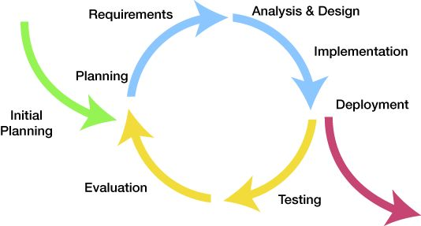  
*Figure 2.1: Iterative and Incremental Software Process Model*

This figure above describes the information and products flow lifecycle process model. Olives project uses the Iterative and Incremental Software Process Model.

The Iterative and Incremental Software Process Model is most use when the scope of the project is big, the major requirements were defined clearly, some more detail will be added in time, and for the newbie group in software development. By using this software process model, we break down the developing system task into series of smaller tasks which be completed separately, evaluated, and subsequently re-worked until the system’s performance adequately. In addition, the iterative model is easier than other models when the issues are discovered. They are fed back to the team, and solutions found while the project is still in development.

* 1. Roles and Responsibilities

2.2.1

* 1. Tools and Techniques